CARLOS MARIO DAZA ATEHORTUA

grado 11¨3

institucion educativa sol de oriente

año 2020

**EJERCICIO 1**

**codigo html:**

**<!DOCTYPE html>**

**<html lang="en">**

**<head>**

**<meta charset="UTF-8">**

**<meta name="viewport" content="width=device-width, initial-scale=1.0">**

**<title>yolo</title>**

**</head>**

**<body>**

**<h1>hola mundo</h1>**

**<script type="text/javascript" src="main.js"></script>**

**</body>**

**</html>**

**codigo js:**

**"use strict"**

**document.querySelector('h1').innerHTML="hola mundo";**

**let tituloEtiqueta=document.querySelector("h1");**

**console.log(tituloEtiqueta);**

**tituloEtiqueta.innerHTML="ESTA VERCION ES MUY ANTIGUA, ATUALIZA A LA VERSION MAS RECIEN ";**

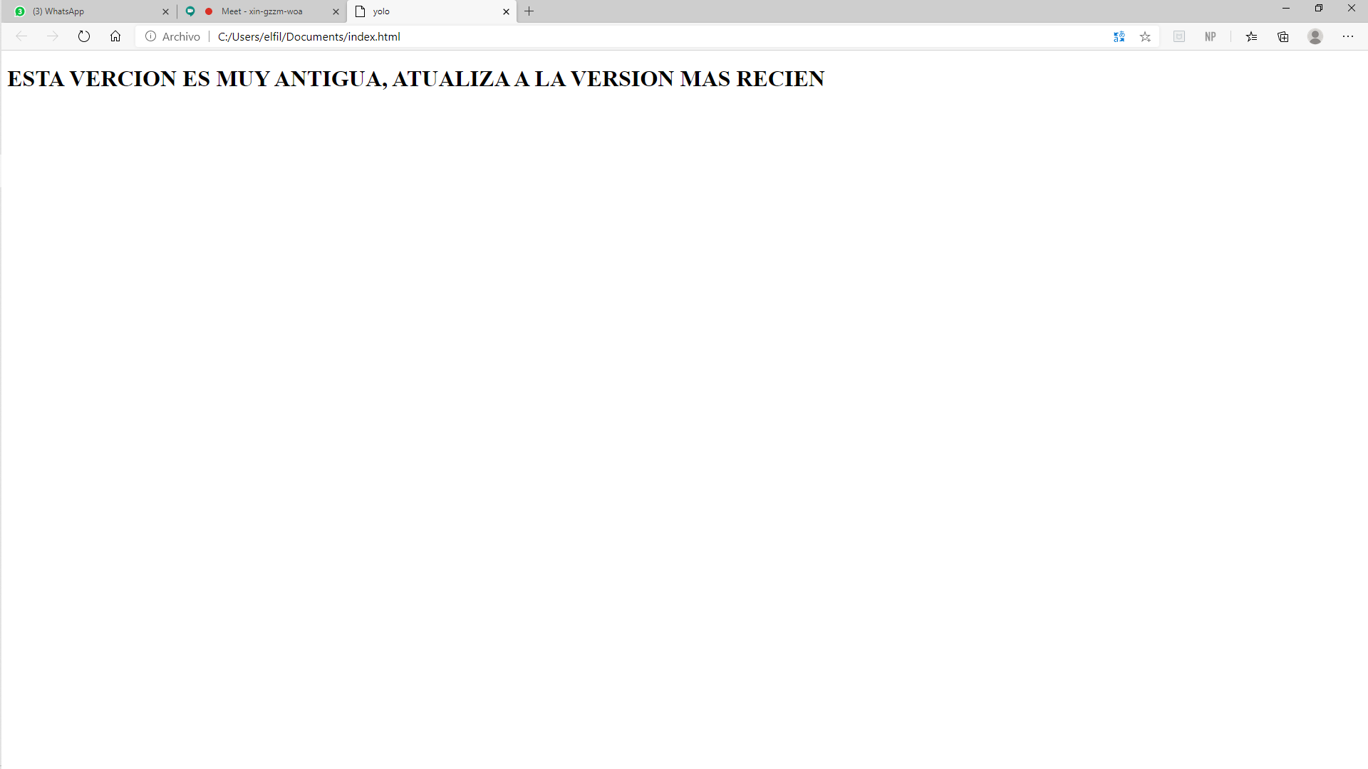

**EJERCICIO 2**

**codigo js:**

**"use strict"**

**const liElement = document.querySelector('.h1');**

**let officeAddress;**

**officeAddress = 'Calle Leganitos, 24';**

**let totalHours;**

**totalHours = 10 + 20 + 30;**

**let officeAddress;**

**officeAddress = 'Calle Leganitos, 24';**

**codigo html:**

**<!DOCTYPE html>**

**<html lang="en">**

**<head>**

**<link rel="stylesheet" href="estilos.css">**

**<meta charset="UTF-8">**

**<title>yolo</title>**

**</head>**

**<body>**

**<h1>**

**<p>explicasion: de el error en pantalla se esta re pitiendo un comando o accion por esto sucede el error mostrado en pantalla,si quitaramos este comando se sumaria las direciones lorem"let officeAddress";</p>**

**</h1>**

**<script type="text/javascript" src="main.js"></script>**

**</body>**

**</html>**

**codigo css:**

**,h1{**

**color: seagreen;**

**margin-bottom: auto;**

**backgrounp{**

**color: rgb(49, 12, 99);**

**}**

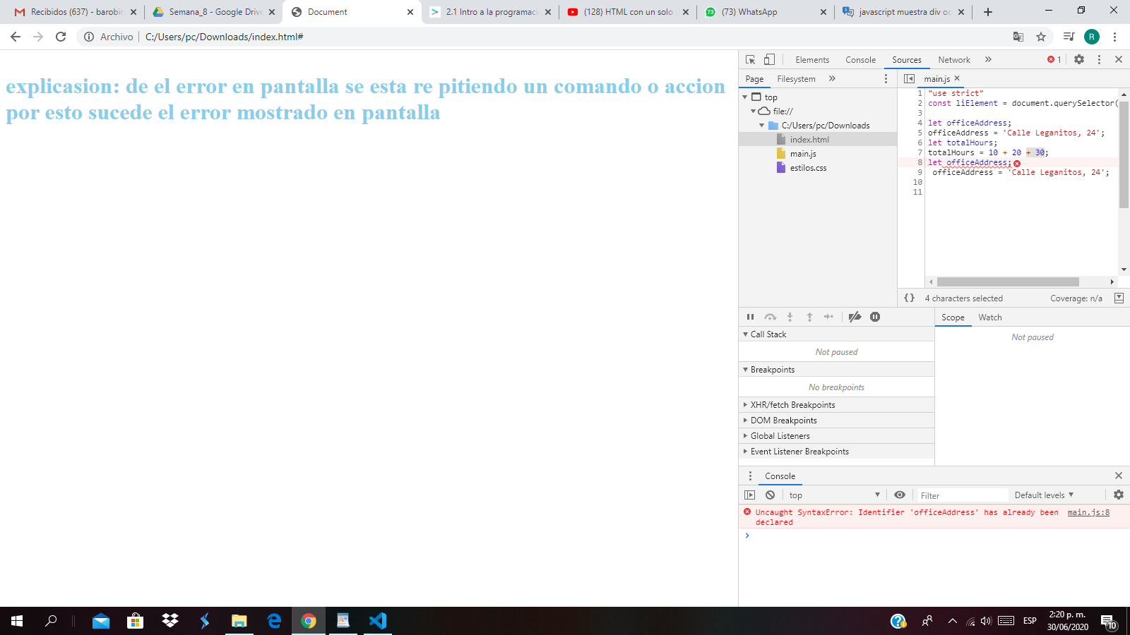

**EJERCICIO 3**

**codigo html:**

**<!DOCTYPE html>**

**<html lang="es">**

**<head>**

**<link rel="stylesheet" href="estilos.css">**

**<meta charset="utf-8">**

**<title>yolo</title>**

**</head>**

**<body>**

**<h1 class="title">hola</h1>**

**<script type="text/javascript" src="main.js"></script>**

**</body>**

**</html>**

**codigo css:**

**.title{**

**color: royalblue;**

**margin: auto;**

**}**

**codigo js:**

**Obtenemos el elemento con el que queremos trabajar usando**

**document.querySelector()**

**\*/**

**const titleElement = document.querySelector('.title');**

**// Cambiamos el contenido del elemento, indicando que sea igual al actual, más una nueva palabra añadida**

**titleElement.innerHTML = titleE/*lement.innerHTML + ', mundo';**

**EJERCICIO 4**

**codigo js:**

**"use strict"**

**document.querySelector('li').innerHTML="La Geek Girl seleccionada es";**

**codigo html:**

**<!DOCTYPE html>**

**<html lang="en">**

**<head>**

**<link rel="stylesheet" href="estilos.css">**

**<meta charset="UTF-8">**

**<meta name="viewport" content="width=device-width, initial-scale=1.0">**

**<title>yolo</title>**

**</head>**

**<body>**

**<ul>**

**<li>robinson</li>**

**<h1>**

**<li>comidas</li>**

**<li > papitas</li>**

**<li >cordones</li>**

**<li > medellin</li>**

**<li >colombia</li>**

**<li >yolunbo</li>**

**<li >cali</li></h1>**

**</ul>**

**<script type="text/javascript" src="main.js"></script>**

**</body>**

**</html>**

**EJERCICIO 5**

**codigo js:**

**"use strict"**

**const liElement = document.querySelector('.li');**

**const content = '<li><a href="#">password</a></li><li><a href="#">*/a></li>';**

**liElement.innerHTML = content;**

**codigo html:**

**<!DOCTYPE html>**

**<html lang="en">**

**<head>**

**<link rel="stylesheet" href="estilos.css">**

**<meta charset="UTF-8">**

**<meta name="viewport" content="width=device-width, initial-scale=1.0">**

**<title>Document</title>**

**</head>**

**<body>**

**<ul>**

**<h1>**

**<ul class="li">**

**<li>"Geek2020"</li>**

**</ul>**

**</ul>**

**<script type="text/javascript" src="main.js"></script>**

**</body>**

**</html>**

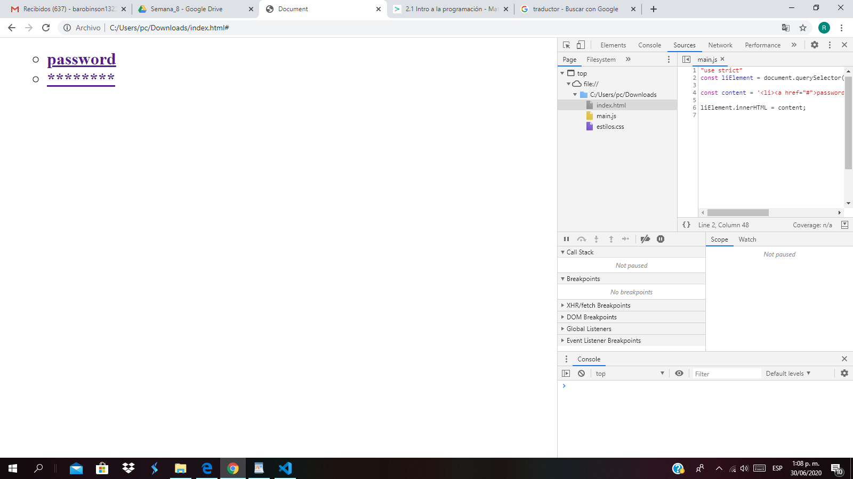

**EJERCICIO 6**

**Lorem ipsum**

**codigo html:**

**<!DOCTYPE html>**

**<html lang="en">**

**<!DOCTYPE html>**

**<html lang="en">**

**<head>**

**<link rel="stylesheet" href="estilos.css">**

**<meta charset="UTF-8">**

**<meta name="viewport" content="width=device-width, initial-scale=1.0">**

**<title>Document</title>**

**</head>**

**<body>**

**<div class="section-robinson">**

**<h1>Lorem ipsum</h1>**

**</div>**

**<script type="text/javascript" src="main.js"></script>**

**</body>**

**</html>**

**codigo js:**

**var robinson = document.querySelector('.section-robinson');**

**robinson.innerHTML= robinson.innerHTML + '<img src="./direccion_imagen.jpg" alt="no hay imagen" />' + '<h1>"Lorem ipsum dolor sit amet, consectetur adipisicing elit".</h1>';**

**EJERCICIO 7**

**codigo html:**

**!DOCTYPE html>**

**<html lang="en">**

**<head>**

**<link rel="stylesheet" href="estilos.css">**

**<meta charset="UTF-8">**

**<meta name="viewport" content="width=device-width, initial-scale=1.0">**

**<title>Document</title>**

**</head>**

**<body>**

**<ul>**

**<h1>**

**<ul class="li"> </ul>**

**<ul>**

**<li></li>**

**<li></li>**

**<li></li>**

**<li></li>**

**<li></li>**

**<li></li>**

**<li></li>**

**</ul>**

**</ul>**

**<script type="text/javascript" src="main.js"></script>**

**</body>**

**</html>**

**codigo js:**

**"use strict"**

**const liElement = document.querySelector('.li');**

**const content = '<li><a href="#">texto 1</a></li><li><a href="#">texto 2</a></li><li><a href="#">texto 3</a></li>';**

**liElement.innerHTML = content;**

**EJERCICIO 8**

**).**

**codigo html:**

**<!DOCTYPE html>**

**<html lang="en">**

**<head>**

**<link rel="stylesheet" href="estilos.css">**

**<meta charset="UTF-8">**

**<meta name="viewport" content="width=device-width, initial-scale=1.0">**

**<title>Document</title>**

**</head>**

**<body>**

**<div class="section-andres">**

**<h1>section andres</h1>**

**</div>**

**<div class="section-robinson">**

**<h1>section robinson</h1>**

**</div>**

**<script type="text/javascript" src="main.js"></script>**

**</body>**

**</html>**

**codigo css:**

**.section-andres{**

**min-height: 20vh;**

**background-color: seagreen;**

**}**

**.section-robinson{**

**min-height: 20vh;**

**background-color: rgb(97, 46, 139);**

**}**

**.hidden {**

**border: solid red;**

**opacity: 0.8;**

**filter: alpha(opacity=80);**

**zoom: 1;**

**}**

**codigo js:**

**const sectionrobinson= document.querySelector(".section-robinson");**

**sectionrobinson.classList.add("hidden");**